### **Sprint 1: Project Proposal**

Ciel Park and Hannah Park

### **Part 1 - Project Requirements**

We propose a campus thrifting website where users can list clothes, furniture, textbooks, and other items. The website will include dynamic behavior through user registration, user login, saving and creating listings, and commenting/messaging sellers. All of these features will allow the front end to respond to user input events and update the interface accordingly. The main features of our campus thrifting website are:

1. **Registration/Login –** The purpose of this feature is to allow users to have unique user profiles associated with their activity and for users to be able to save their data. This feature will verify user credentials and grant them access to the app and profile. In order to use this feature, new users will create an account during onboarding of their account or before saving, messaging, or creating other profile related information. Old users will be prompted to sign in. The website will only allow accounts created with UVA emails for student safety and validation. The users can expect proper validation checks and secure password handling. No sensitive information such as payment methods or address will be saved to the profile in order to increase security.
2. **Creating Listings** – The purpose of this feature is to allow all users to list their items or services, which will allow others to browse and select their uploaded listings. This feature will provide a form or interface where users can input details about their item including name, description, price, category, and optional contact information such as a venmo username. In order to use this feature, users will access the “create listing” feature from the profile screen, fill out the required fields with accurate information about their item/service, and post the listing. The users can expect detailed listings posted onto their account to ensure transparency of product being sold.
3. **Saving Listings** – The purpose of this feature is to allow users to save any potential listings that other users have posted. This feature will save listings to users' profiles when indicated. In order to use this feature, users will press the “save” icon that is made available on the listing to come back to at a different time or to view later. Users will be able to view all of their saved listings in one page. Users can expect to successfully save listings based on their preferences and view them at a later time.
4. **Messaging Sellers** – The purpose of this feature is to allow users to communicate with other users of the application to coordinate payment and pickup. This feature will provide a dedicated direct message page for all of a user's conversations. In order to use this feature, buyers will press the message button to send a private message to the seller. Users can expect to send and receive messages privately and also go back to view all of their previous conversations in the messages tab.
5. **Searching/Filtering Listing**s – The purpose of this feature is to allow users to have refined and specific searches. This feature will allow users to search specific categories or details of a listing as well as refine their search results. In order to use this feature, users will be able to enter their specific search in the search bar. To refine their search, users will be able to press the filter icon that will lead them to a dropdown of different filtering options that will further refine their search results. Users can expect to successfully search for items based on their search and filtering options that match their inputted options.

Our project will include logic that will execute the client side in a web browser through new listing form validation and filtering/sorting through listings. It will include logic that will execute the backend component of the web server through the adding, updating, deleting, and retrieving of a listing and profile data from a database. It will support multiple users by having anyone with a valid uva email sign up and use the account simultaneously with a different user. It will support multiple sessions by allowing users to retrieve previously saved listings, edit listings, or retrieve comments.

## **Part 2 - User Interface Design**

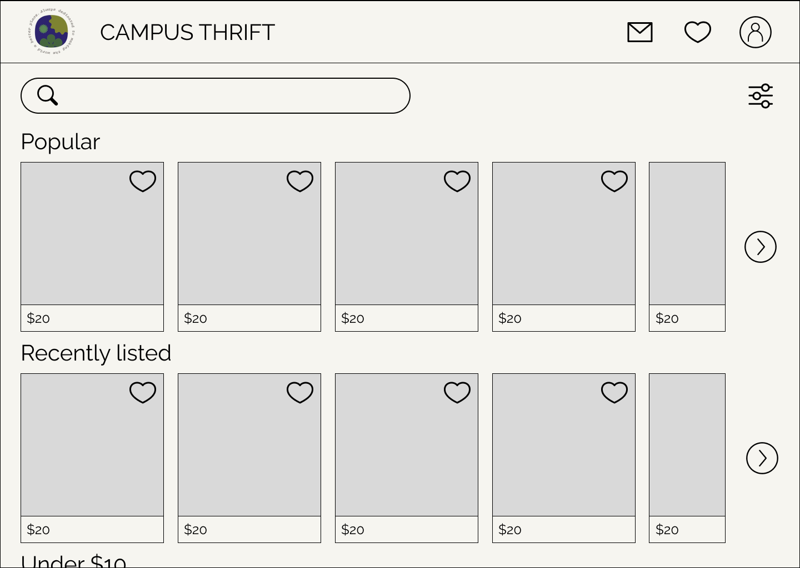

The home screen is very simple, with a search bar and filter button at the top, and a grid of item listings split into labeled rows, breaking up the feed visually and categorically. Splitting the main feed up this way leads to a more structured browsing experience than just having all the items in one grid. The arrows on the right essentially provide filtering shortcuts, so the user can see all of the listings of that category. The item listings on the home page show the cover picture and price of the image, and the like button is prominent so users can easily save items for later.

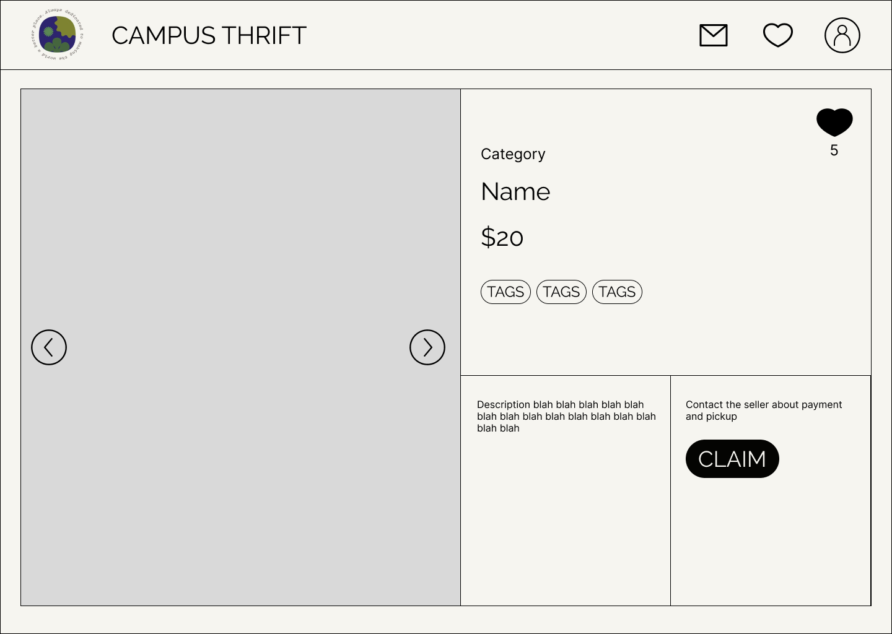

Clicking on any of the item listings brings you to the item details page, which has all of the relevant information a user needs to know before making a purchase. The images are on the left half, all of the item’s associated information are listed in the top section, the description is on the bottom left, and the checkout button is on the bottom right. The like button is on the top right of the page, consistent with the listings on the home page. The item’s information is broken up in four sections so none are too information-dense, and placing the checkout button on the bottom right is intuitive for users accustomed to western reading patterns.

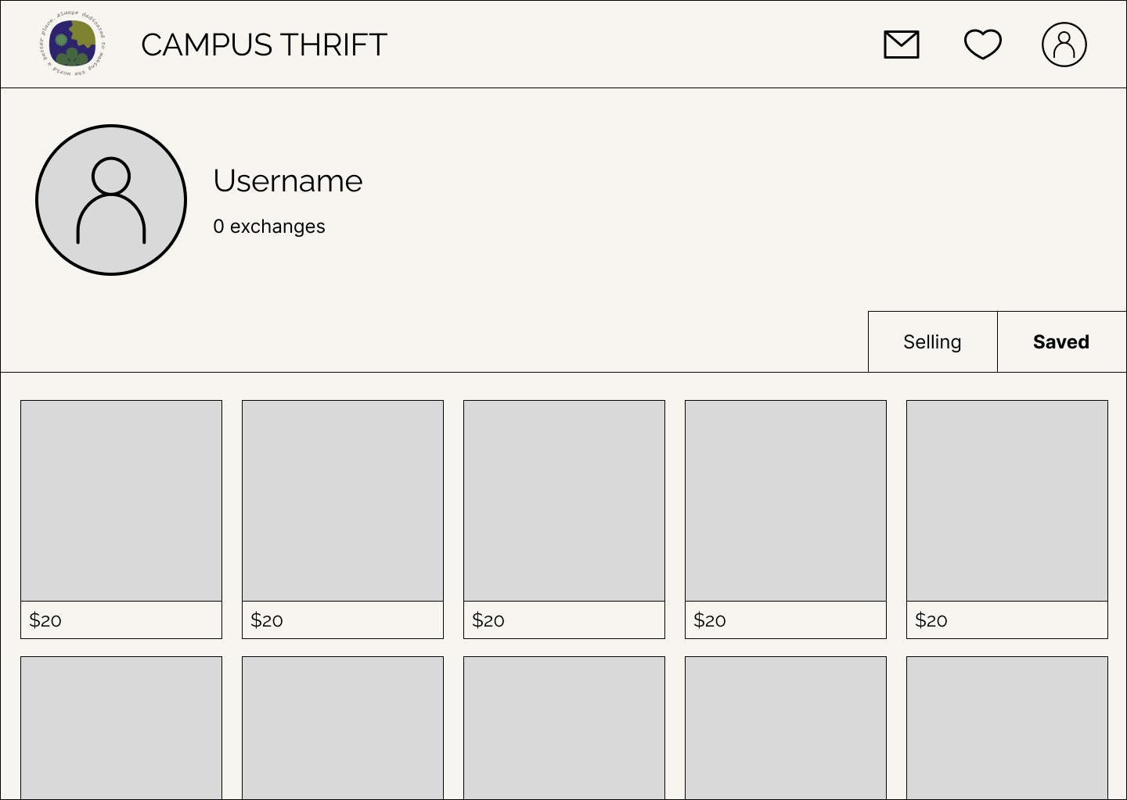

Finally, the profile screen shows the user’s profile image, username, and previous transactions, with two tabs for items they are selling and items they are interested in buying. Tabbed navigation allows users to switch between selling and buying activities seamlessly, encouraging all users to engage in both sides of the platform. Displaying previous transactions enhances transparency and builds trust between users by demonstrating experience with the platform, and the heart button is removed as it is obvious that all of the items on the profile have already been saved before, and to discourage accidental removal of a listing.